Appendix E

Data Migration Process Flow Design Template

The Data Migration Process Flow provides a detailed design for migration processes, including the order of operations. It can be considered a technical appendix to the Data Migration Strategy, intended to provide the step-by-step processes that fulfill the proposal offered in that document. This document tracks the migration at a granular level and, therefore, should be updated and reviewed after each change in scope to ensure the requirements still are in alignment with stakeholder expectations.

# Order of Operation

[Describe the step-by-step operation for object migration. For example:]

This document defines the process flow for development, deployment, and clean up required to migrate the stakeholder’s list of data. These activities can vary in time, depending on the volume of data provided and the complexity of updates.

The integration team presents the breakdown for deployment to Development, Test, and Production environment in Figure 1. These individual steps performed for each task are summarized later in this document.



Figure 1: Sample Project Flow

# Mapping Logic

[This section defines the high-level rules for migrating source-to-target data, mostly used to confirm with the client that these migrations are accurate. You will be referencing your Source to Target Mapping spreadsheet at some point in this section. As indicated throughout this book, the spreadsheet should be available in a separate spreadsheet or database, and you can include a summary table for easy reference. For example:]

Due to currently existing duplications as well as priority field determination, the integration team has included business logic as part of the ETL process. In collaboration with stakeholder requirements, the integration team has summarized the business rules for populating the target data store. The source-to-target maps below identify these transformation rules (last column) as well as the Source System, the source Location (i.e., the database or CSV file containing all deduplicated records), the Source Field name, and the target object and field. Table 1 shows the field mapping for the MYCONTACTDB Source System to the CONTACT Target.

Table 1: Field Mappings for the MYCONTACTDB Source System

|  |  |  |  |  |  |
| --- | --- | --- | --- | --- | --- |
| Source System | Source Location | Source Field | Target Object | Target Field | Transformation Rule |
| MYCONTACTDB | Contact_Users | Full_Name | CONTACT | FIRSTNAME | Extract first name from source with following rule: (EXTRACT,Full_Name, “ “) |
| MYCONTACTDB | Contact_Users | Full_Name | CONTACT | MIDDLENAME | Extract first name from source with following rule: (EXTRACT,Full_Name, “ “, “ “) |
| MYCONTACTDB | Contact_Users | Full_Name | CONTACT | LASTNAME | Extract first name from source with following rule: (EXTRACT FROM RIGHT,Full_Name, “ “) |
| MYCONTACTDB | EMAIL spreadsheet | email | CONTACT | EMAIL | Direct transform ation (note: only the first EMAIL value from the EMAIL table will be used; the second value (EMAIL) will be added to CONTACT.Description field |

# Deployment Steps

[Define each step of the process that will occur during migration, along with a detailed description. The resulting flowchart should provide context for stakeholders and developers as well as a guide for deployment. Each step should then be summarized in a single sentence. For example:]



Figure 2: Step-By-Step Deployment Step

## Description of Pre-Requisites

* Step 0: Receive records for review, evaluate if existing IDs link with existing Contact Data (based on LEGACY_ID keys). Create lists of updates versus inserts based on found values.

## Contact

* Step 1: Insert Sample Contact Records into PreProduction: 5-10 sample contact records will bulk load via the Oracle SQL*Loader tool.
* Step 2: QA Assessment of 5-10 records with feedback followed by reiteration/deletion of sample records/reload (if needed)
* Step 3: Migrate remaining Contacts through Oracle SQL*Loader tool
* Step 4: Final check of records loaded/send out log files
* Steps 5 – 8: Repeat process in the Production environment

# Account

* Step 9: Perform export of CONTACT object stored in Production and import into Staging Database for reference lookup
* Step 10: Update Account Record Sample, followed by QA assessment with feedback. (should take no longer than 1 hour)
* Step 11: Update full Account load in the Production environment

## Project Signoff/Document Delivery

* During this final phase, the project will receive authorized signoff and a final document will be placed into Salesforce Content as a reference package.

# Log File Delivery

[Indicates where the Deployment Success and Error Logs will be stored. For example:]

## Individual Delivery

At the end of each stage, log files identifying the individual SUCCESS and ERRORS (i.e., fallout) will be available for review. Oracle SQL*Loader will provide this file in a log report which team members can reach from the corporate Q:\ drive.

Success and Errors counts, as well as load time, will also be tracked separately in spreadsheets to ensure appropriate benchmarking.

## Portal Storage

Data logs for all deployments, both test as well as production, are archived in Sharepoint and available for review from <https://corporatesharepointwebsite.com>.

# Migration Results

[Once the migration is complete, record the high-level Success and Error results and any additional notes for each object. For example:]

## Contact

### Inserts

* # Records Inserted: 200000
* # Successes: 145158
* # Failures: 54842
* Due to field names being incorrect, the majority of errors were for empty Last Name (53,811) and First Name (1,031) fields.

### Updates

* # Records Updated: 26,079
* 100% Success

## Account

* # New Records Updated: 92192
* # Existing Records Updated : 36
* 100% Success

# Final Signoff

[As a final step, prepare an email screenshot from the project sponsor or product owner that the deployment was successful, and the target system received the data per requirements. Generally, this signoff happens after deployment and establishes that the right people were satisfied with the deployment results. For example:]

The Project Sponsor has confirmed that the target data source on 12/22/2019 successfully received Production Contact and Account data (see Figure 3), thereby concluding this migration.

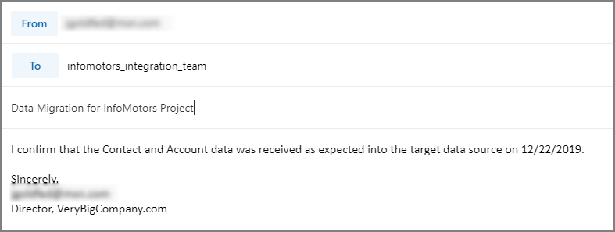

Figure 3: Sample Project Flow